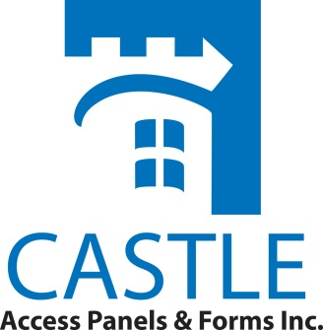
CASTLE ACCESS PANELS & FORMS INC.
173 ADESSO DR, UNIT 2
CONCORD, ON, L4K 3C3, CANADA

Phone: (905)738-8089
Fax: (905)760-9234
Website: WWW.CASTLEACCESSPANELS.COM
Email: SALE@CASTLEACCESSPANELS.COM

OPERATION & MAINTENANCE INSTRUCTIONS
ACCESS PANELS & DOORS

- Unit(s) received are unpainted natural grey gypsum and require prime painted finish, and they need to be coated with a finishing coat of paint.

Door Operation
1. Open Latch(es)
Access Doors w/ Cylinder Locks:
All locks must be in the “Unlocked” position to allow the unit’s door panel to open freely. To unlock the Cylinder Lock, insert key provided and turn the key clockwise. If there are other Slotted Cam Latches on the door in addition to the Cylinder Lock, they must also be turned into an “Open” position. (See Instruction Below for Slotted Cam latches).

Access Doors w/ Screwdriver Operated (Slotted Cam - Latches):
All screwdriver latch(es) must be turned into the “open” position. Use a standard screwdriver to turn the latch(es).

- Opening Panel
All units with have flush Slotted Cam Latches or Keyed Alike Cam Latches, the panel is “Notched Out” for a flush appearance.
Note - there should be no pressure necessary to pry this panel open if all of the catches are in the “Open” position.

Repair or Exchange of Hardware:
Please contact Castle Access Panels, Inc. if it is determined that a part needs to be replaced. Most items cannot be replaced separately causing the entire unit to be replaced. (905)738-8089

