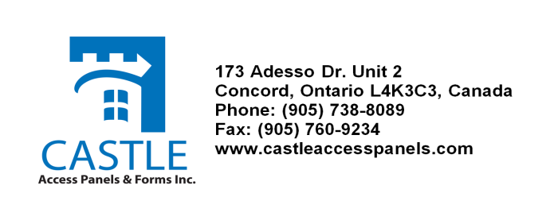
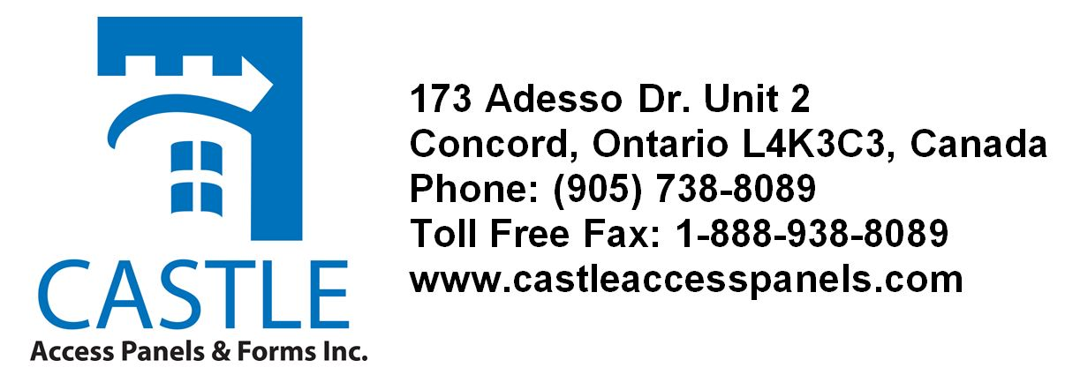

CASTLE ACCESS PANELS & FORMS INC. WARRANTY

Castle Access Panels & Forms Inc. warrants its GRG/GFRG/GFRC access door, column cover and shapes as follows:

WARRANTY :

1. Castle Access Panels & Forms Inc. warrants that the delivered material supplied will conform to sample and to specifications and will be free from defects in material and workmanship under normal use and conditions for a period of three years from date of shipment. Should manufacturer defects appear within one year of the date of shipment, Castle Access Panels & Forms Inc. has the option of replacing or repairing the defective material.

2. Limitations: The aforementioned general warranty is exclusive. All other warranties whether expressed or implied or arising by operation of law, usage of trade, course of dealings or otherwise, are excluded. The only warranties are those expressed above. Castle Access Panels & Forms Inc. shall not be liable for installation costs, freight any penalty or for any loss or damages associated with the removal or installation of its product or claims of third parties against the Purchaser.

